National Dashboard

Note that this Power BI Dashboard also included a separate State dashboard (not shown) that had a dropdown where you could select a state to see the same line and are a charts, but by each state (so more than fifty pages within dashboard)

First tab of dashboard: Note that dashboards are automatically interactive. Below, the user hovers over a week in April 2023, and a box automatically pops up to show the COVID case rate by age group for that week in April 2023

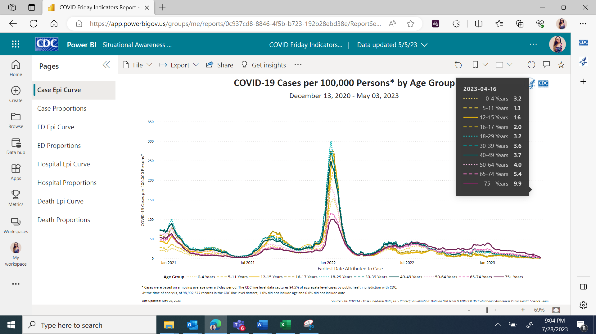

Second tab in dashboard – shows that in Power BI, programmer made a pivot table (aggregating cases by age), line chart, and area chart

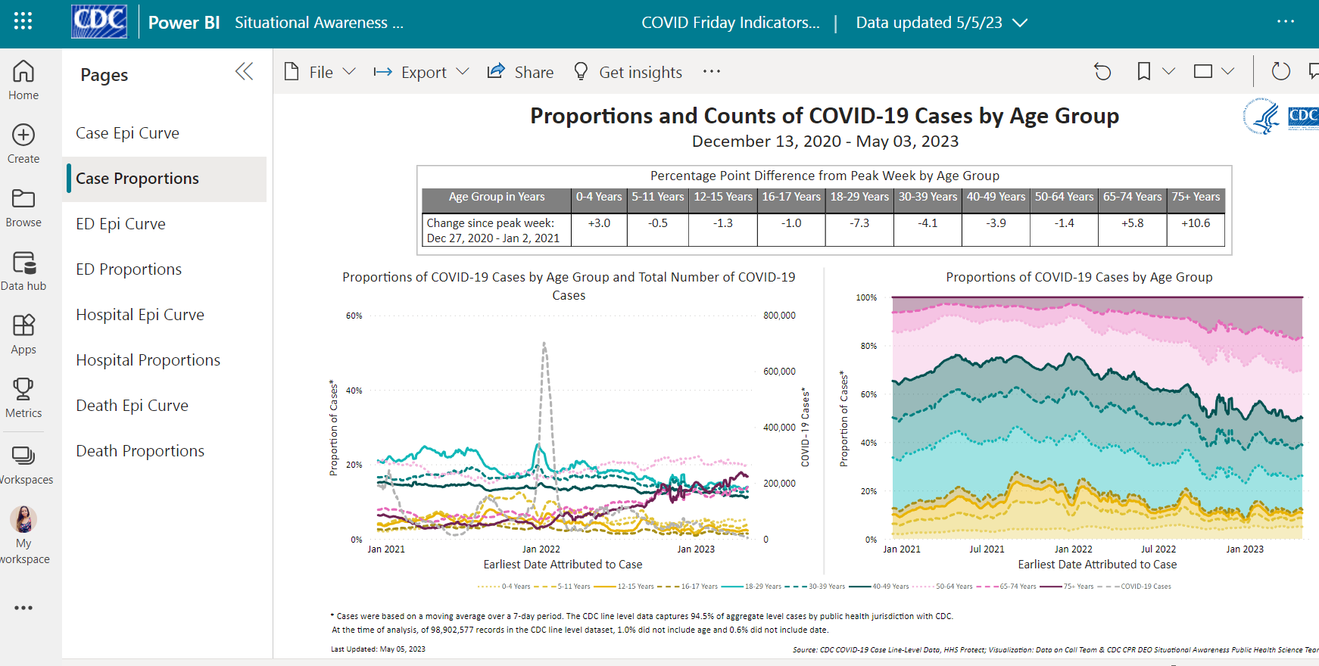

Third tab in dashboard

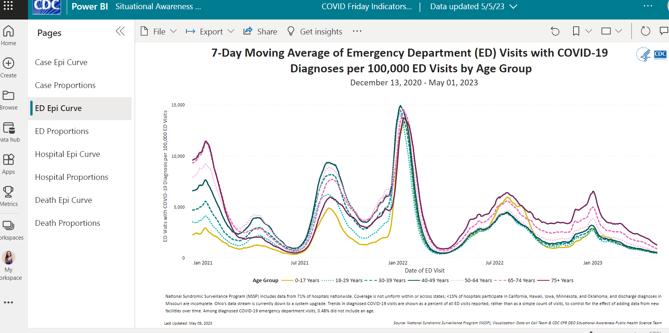

Fourth Tab in dashboard:

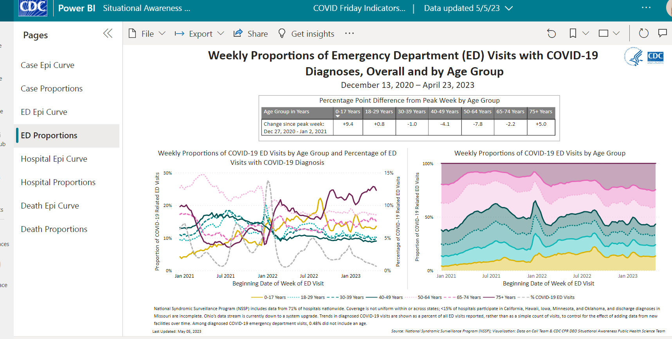

Fifth tab in dashboard:

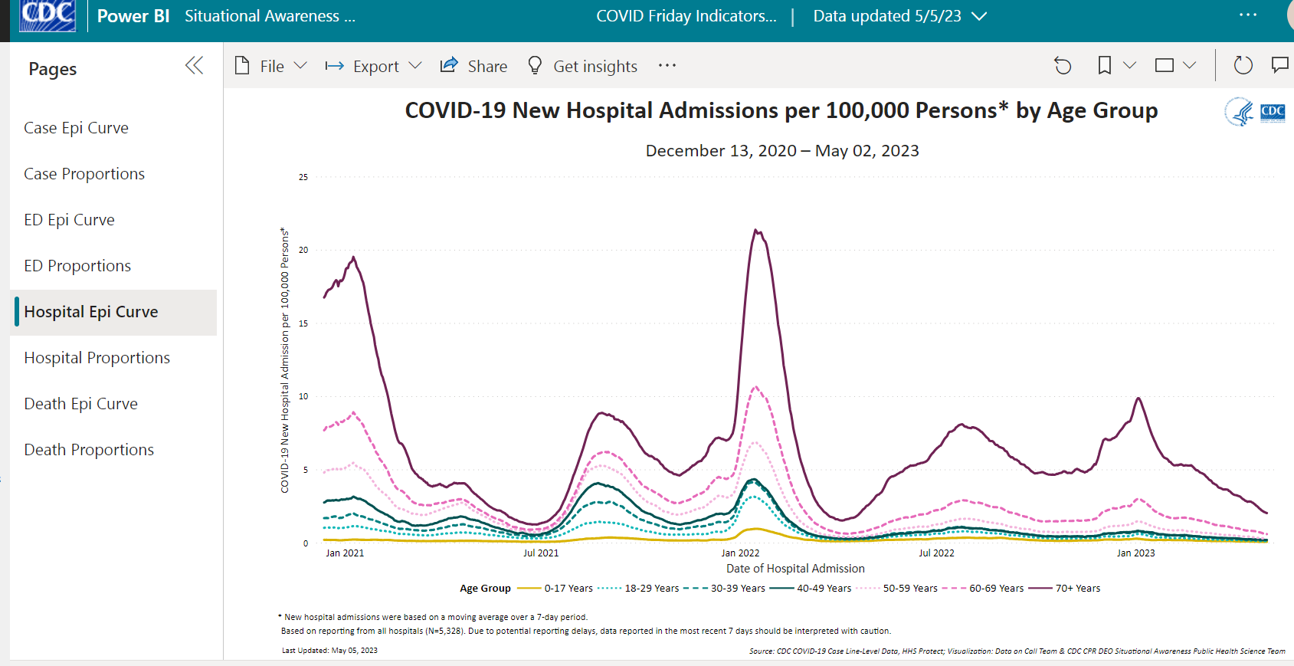

Sixth tab in Dashboard:

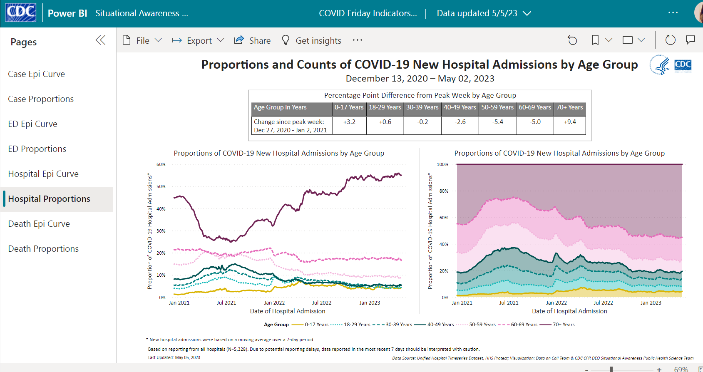

Seventh Tab in dashboard

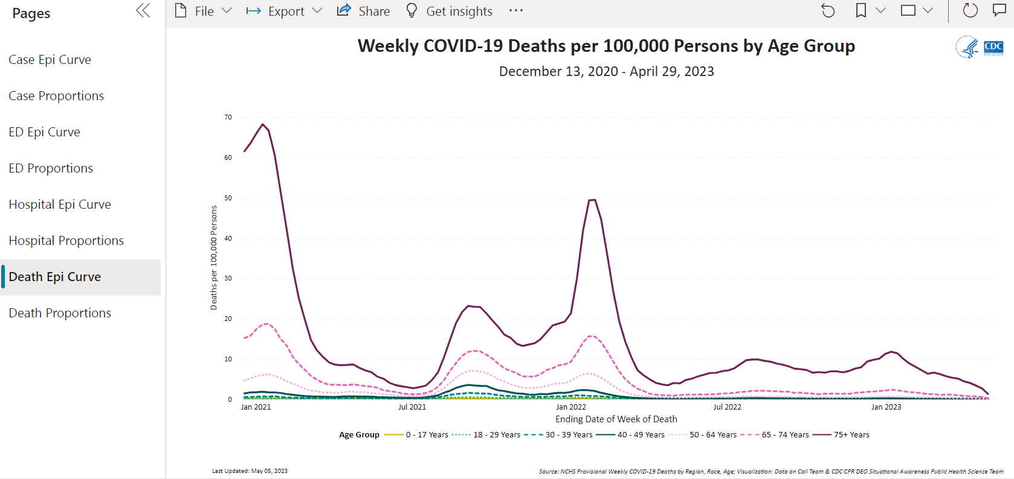

Eighth tab in dashboard – Note that dashboards are automatically interactive. Below, the user hovers over a week in July, and a box automatically pops up to show the specific stats for July

